PIZZA SALES SQL QUERIES
A. KPI’s
1. Total revenue
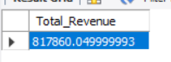
SELECT sum(total_price) AS Total_Revenue FROM pizza_sales

2. Average Order Value
SELECT (SUM(total_price) / COUNT(DISTINCT order_id)) AS Avg_order_Value FROM pizza_sales
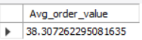
3. Total Pizaa Sold
SELECT SUM(quantity) As Total_pizzas_sold FROM pizza_sales;
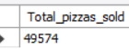
4. Total Orders
SELECT count(distinct order_id) AS Total_orders from pizza_sales;
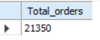
5. 5. Average Pizzas Per Order
SELECT CAST(CAST(SUM(quantity) AS DECIMAL(10,2)) /
CAST(COUNT(DISTINCT order_id) AS DECIMAL(10,2)) AS DECIMAL(10,2))
AS Avg_Pizzas_per_order
FROM pizza_sales
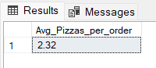

B. Daily Trends For Total Orders
SELECT DAYNAME(order_date_fixed) AS order_day, COUNT(DISTINCT order_id) AS Total_orders
FROM pizza_sales GROUP BY DAYNAME(order_date_fixed), DAYOFWEEK(order_date_fixed)
ORDER BY DAYOFWEEK(order_date_fixed);
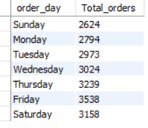

C. Monthly Trends for orders
SELECT monthname(Order_date_fixed) AS order_month, COUNT(Distinct order_id) AS Total_orders
from pizza_sales group by monthname(Order_date_fixed),month(Order_date_fixed)
ORDER BY month(order_date_fixed);
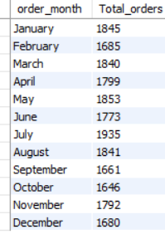

D. % of Sale by Pizza Category
SELECT pizza_category, ROUND(SUM(total_price) * 100 / (SELECT SUM(total_price) FROM pizza_sales), 2) AS percentage_contribution FROM pizza_sales GROUP BY pizza_category ORDER BY percentage_contribution DESC;
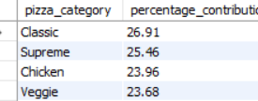

E. % of Sale By Pizza Size
SELECT pizza_size, ROUND(SUM(total_price) * 100 / (SELECT SUM(total_price) FROM pizza_sales WHERE quarter(order_date_fixed) = 1) , 2) AS percentage_contribution FROM pizza_sales WHERE quarter(order_date_fixed) = 1 GROUP BY pizza_size ORDER BY percentage_contribution DESC;
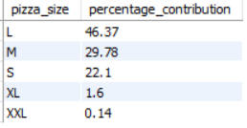

F. Total Pizzas Sold by Pizza Category
SELECT pizza_category, SUM(quantity) as Total_Quantity_Sold
FROM pizza_sales
WHERE MONTH(order_date) = 2
GROUP BY pizza_category
ORDER BY Total_Quantity_Sold DESC
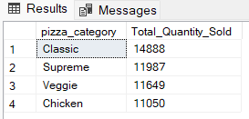

G. Top 5 Pizzas By Revenue
SELECT pizza_name,SUM(total_price) AS Total_Revnue from pizza_salesgroup by pizza_name order by SUM(total_price) DESC limit 5
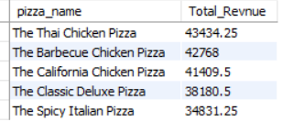
H.Bottom 5 Pizzas Revnue
SELECT pizza_name,SUM(total_price) AS Total_Revnue from pizza_salesgroup by pizza_name
order by SUM(total_price) ASC limit 5
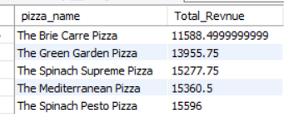
I.Top 5 Pizzas By Quantity
SELECT pizza_name, SUM(quantity) as Total_Quantity from pizza_sales group by pizza_name order by SUM(quantity) DESC limit 5
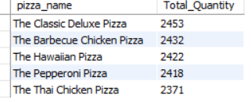

J. Bottom 5 Pizzas By Quantity
SELECT pizza_name, SUM(quantity) as Total_Quantity from pizza_sales group by pizza_name
order by SUM(quantity) ASC limit 5
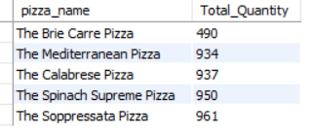
K. Top 5 pizzas By Total Orders
SELECT pizza_name, COUNT(distinct order_id) as Total_orders from pizza_sales group by pizza_name order by COUNT(distinct order_id) DESC limit 5
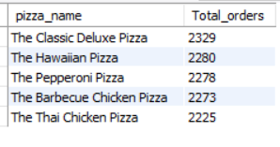
L. Bottom 5 Pizzas By Toatl Orders
SELECT pizza_name, COUNT(distinct order_id) as Total_orders from pizza_sales group by pizza_name order by COUNT(distinct order_id) ASC limit 5
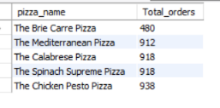

NOTE
If you want to apply the pizza_category or pizza_size filters to the above queries you can use WHERE clause. Follow some of below examples
SELECT Top 5 pizza_name, COUNT(DISTINCT order_id) AS Total_Orders
FROM pizza_sales
WHERE pizza_category = 'Classic'
GROUP BY pizza_name
ORDER BY Total_Orders ASC

